Cosc363 Assignment 2

Jordan Withell

67307220

# Features

I have done all the minimum requirements as well as the following extra features:

* Refraction through an object.
* Multiple reflections through parallel mirrors-like objects.
* Adaptive anti-aliasing.
* A procedural pattern generated on any surface.
* Stochastic sampling (Soft shadows).
* A screenshot of a computer game

  Description automatically generatedConstructive Solid Geometry

Figure 1

# Failures

Some things my ray tracer hasn’t done well is Torus’. There is code included that renders a torus object but not successfully. it creates a donut shape but doesn’t look 3d and the lightning on it is incorrect. Because of this, I chose not to include it in the rendered image, but the code for it remains in the submission.

Another failure is the time it takes to render with everything on. 360 seconds or 6 minutes. Turning off Anti-Aliasing brings it down to 20 seconds and turning off soft shadows as well brings it down to 2.5 seconds. One reason for the huge increase in time could be because of the procedurally generated texture having a lot of edges and causing a lot more traces.

# Refraction

The middle sphere in Figure 1 is refractive and has a refraction index of 1.5. It also has a lighter shadow than the other objects in the scene.

# Multiple reflections through parallel mirrors-like objects

On the far yellow wall, there is a mirror in the center. The reflection you can see is the red wall behind the camera, which also has a mirror. In the center of the reflections is a blue square, this is the base colour of the mirror and is being shown because the max reflections have been reached, which is 10.

# A procedural pattern generated on any surface

On the right wall, the Mandelbrot set is generated and rendered on the plane. This is done by getting the y and z coordinates of the ray hit on the plane. The Mandelbrot set is generated by starting at 0 with 2 variables, zi and zr.

$${zi}_{0}=0$$

$${zr}_{0}=0$$

Then increasing them using the input parameters, which are the x and y coordinates of the hit.

If zi2 goes above 4, it is considered to go to infinity. If after 20 iterations, it has not gone past 4, it is considered to stay under 4 forever. Then using the amount of iterations, the hue of the plane is calculated by using

$$hue=\frac{n*360}{20}$$

Then using a hsv to rgb function to return the color of the plane.

# Constructive Solid Geometry

A CSG as seen on the right side of figure 1, was constructed from 2 spheres using subtraction. The 2 spheres have the same radius, and the 2nd sphere is moved -1 unit in the x axis. The 2nd sphere is subtracted from the 1st sphere.

# Soft shadows

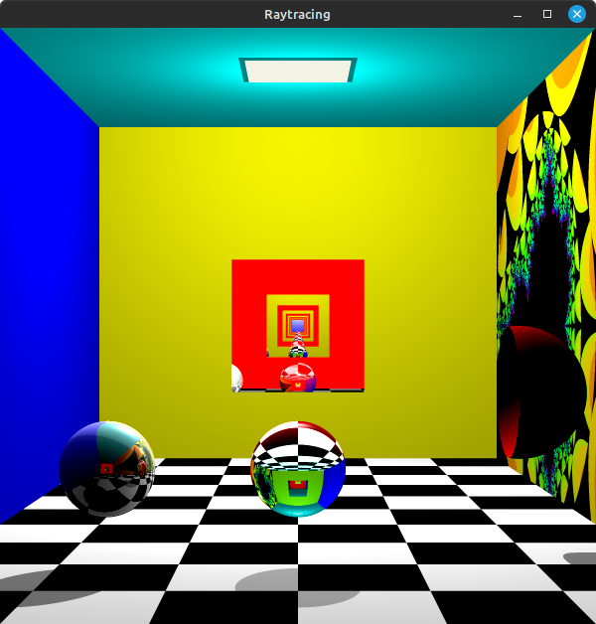Soft shadows are included in figure 1, figure 2 shows the same scene without soft shadows. This is done by changing the direction of the shadow ray randomly so it has a more realistic appearance.

Figure 2

# Adaptive anti-aliasing

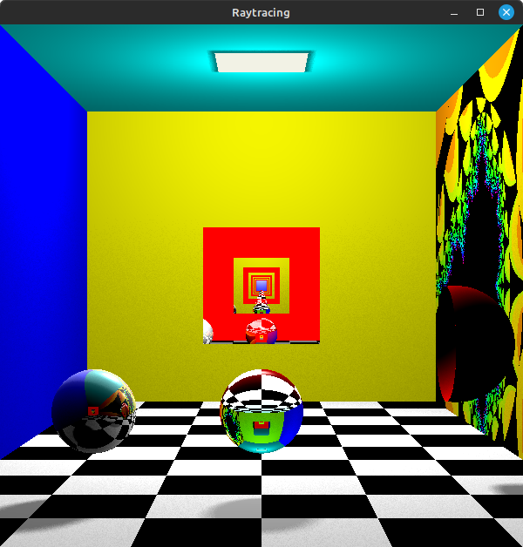Adaptive Anti-Aliasing or AAA is used in this raytracer. It works by sending 1 ray for every pixel on the screen and saving the color to an array. It then loops through the array and if any pixel has a different color to its neighbours, it splits up the pixel into quarters and sends 4 more rays, the result is averaged set to the pixel. This increases the time to render significantly but makes the render more realistic by smoothing out edges. Figure 3 shows the same scene as Figure 1 but without any Anti-Aliasing.

Figure 3

# Transparent Object

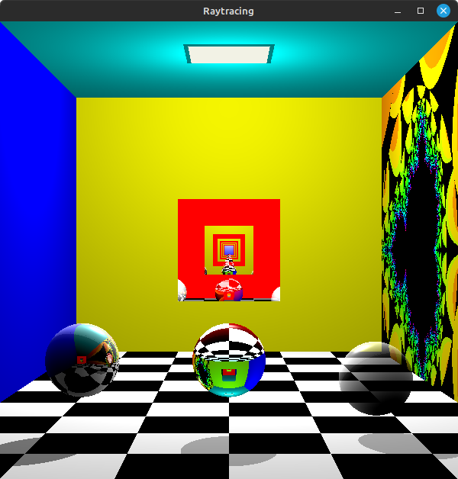Figure 1 does not show a transparent object, but Figure 4 shows one on the right, that is white and has a transparency index of 0.5. Please note that this render does not include soft shadows or AAA.

# Build instructions

This was developed in VSCode on linux using Cmake. To build, use Cmake with the CmakeLists.txt file to build and run.

# Declaration

I declare that this assignment submission represents my own work (except for

allowed material provided in the course), and that ideas or extracts from other

sources are properly acknowledged in the report. I have not allowed anyone to copy

my work with the intention of passing it off as their own work.

Name: Jordan Withell

Student ID: 67307220

Date 31/05/24